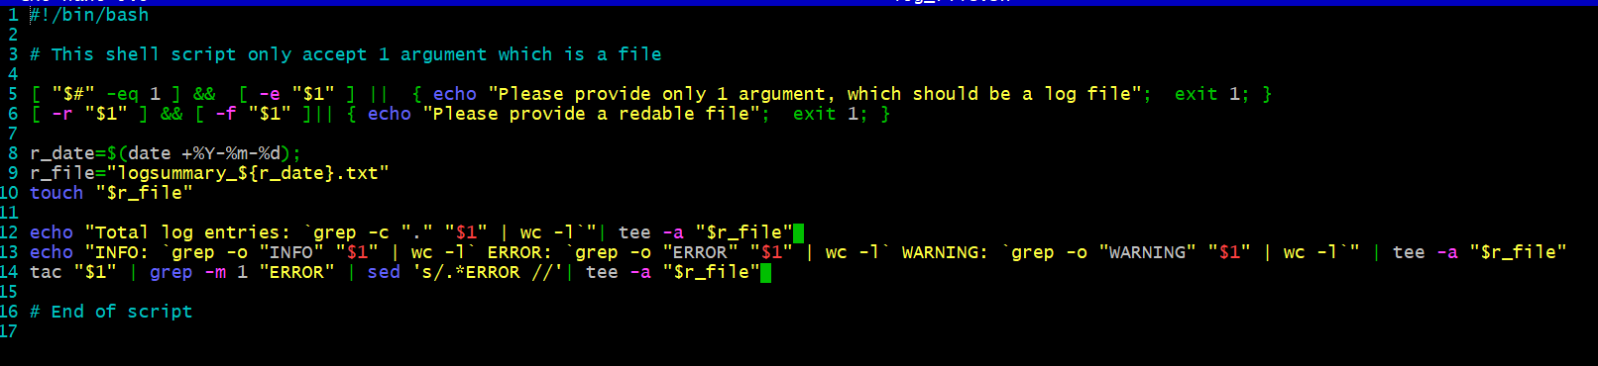
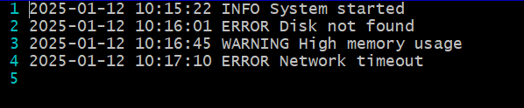
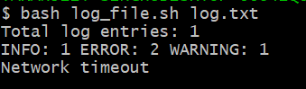
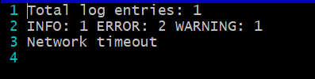
Explanation: So my script validates if only one argument is passed which should be a log file and then as desired creates a log_summary file with the date and append as well as show output on the screen with help of tee command. Handles error message plus displays desired output. Files are created and all the screenshots are added.

